SOUTH DISTRICT COUNCIL OF CATHOLIC WOMEN

CELEBRATES OUR FOURTH ANNUAL AFTERNOON TEA

**Saturday, January 31, 2015**

**Holy Rosary – St. Richard**

**7500 SW 152 Street**

**Miami, FL 33157**

**2:00 pm to 4:00pm**

**Donation: $20. Per Person**

**Please RSVP to**

**Margaret Wright**

**305-812-7746 or** [**mmwright47@aol.com**](mailto:mmwright47@aol.com)



**History of the Afternoon Tea Party**

While drinking tea as a fashionable event is credited to Catharine of Braganza, the actual taking of tea in the afternoon developed into a [new](http://www.afternoontoremember.com/learn/etiquette) social event sometime in the late 1830’s and early 1840’s. Jane Austen hints of afternoon tea as early as 1804 in an unfinished novel. It is said that the afternoon tea tradition was established by Anne, Duchess of Bedford. She requested that light sandwiches be brought to her in the late afternoon because she had a “sinking feeling” during that time because of the long gap between meals. She began to invite others to join her and thus became the tradition.

**ADDING to the ATMOSPHERE**

This year we will have a contest in four categories.

Three secret Judges have been selected to pick a winner for each type of hat.

Victorian 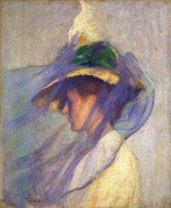 Vintage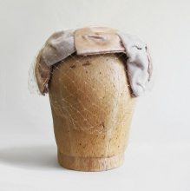 Flowers Feathers

**Come join the fun! Glam it Up!**