Miami Archdiocesan Council of Catholic Women
Annual Fundraiser - Book Review and Luncheon
Chinese Auction & Pot ‘o Gold
Saturday, November 4, 2017
Colony West Golf Club
6800 NW 88th Avenue
Tamarac, Florida 33321
10:00 A.M. – 2:00P.M
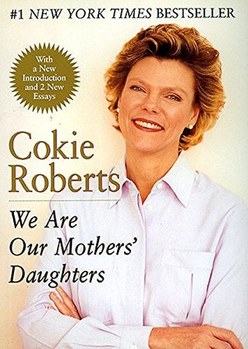
Cokie Roberts' lifetime interest has been the advancement of girls and women. This biography spotlights womens' struggles for equity in jobs and in pay, academe, sports, politics and more. Along with the broader story- a history of American women - is her personal story, a journey that women of our generation might well find resonates with their own lives.
Presenter: Audrey Saunders
*******************************************************************
Served Luncheon
Entrée Garden Salad topped with choice of: Grilled Chicken Breast or Grilled Salmon
Dinner Roll and Butter, Key Lime Pie, Coffee, Tea, Decaf and Iced Tea

DONATION $28.00
Checks payable to: MACCW
RSVP: Josephine Gilbert 305-510-3163 or nikeglad@aol.com (Deadline 10/25/2017)
9000 N. Lake Dasha Drive
Plantation , FL 33324

